Dear Class,

I am Elizabeth Mulcahy and 2016-17 is my 11th year teaching at WAHS. This coming year I will be teaching AP World History and ESA Geography. Of course I love history, but I also like to be active outside the classroom here at WAHS. I am currently the Social Studies Honor Society sponsor. I have also coached basketball and softball, been a class sponsor, and taken students on European adventures. In your letters please let me know about activities that you are participating in or would like to participate in at WAHS and outside of school.

Outside of school my world revolves around my family and the numerous sports that we support. My son Ethan is eight. He currently loves Pokémon and plays basketball, football, baseball, and wrestles. My house is also cluttered with anything Frozen, Alvin & Chipmunks, or Ninja Turtles for my five year old daughter Abigail. The Virginia Cavaliers, Buffalo Bills, and Detroit Tigers take up a great deal of our leisure time as we are avid fans and try to attend as many games possible. All Hokies, Patriots, or Yankees please tread lightly. Finally, do not get confused if you see Mulcahy connected to science. My husband also teaches science at WAHS and is the wrestling coach.

For leisure time, I mainly read historical fiction and non-fiction (what a surprise). *Boys in the Boat* is probably the best book I have read recently. To make myself write more I started a blog on world historical connections called smallworldonehistory.blogspot.com. Probably my top three TV shows are Sports Center, Jeopardy, and Criminal Minds.

The periods of history that fascinate me change on a daily basis. When I was in middle and high school it was the American Civil War. I begged my parents to go on vacation in Gettysburg. When I was in college it was ‘60s American history (especially the space program) so I got my parents to take us to the Kennedy Space Center. When I started teaching I was thrown into a more international realm of study especially after working in an American school in Switzerland for a summer. I have traveled throughout Europe and China with students and other teachers with Venice and Shanghai topping my lists. As far as AP World goes I find the dysfunctional stories of monarchs and gaining or losing power fascinating. The French Revolution and decolonization especially pull at the historian in me and not just because of the bloodshed, but because of the world shift of ideas that occur.

I hope everyone has a great year, and I look forward to reading your letters.

Mrs. Mulcahy

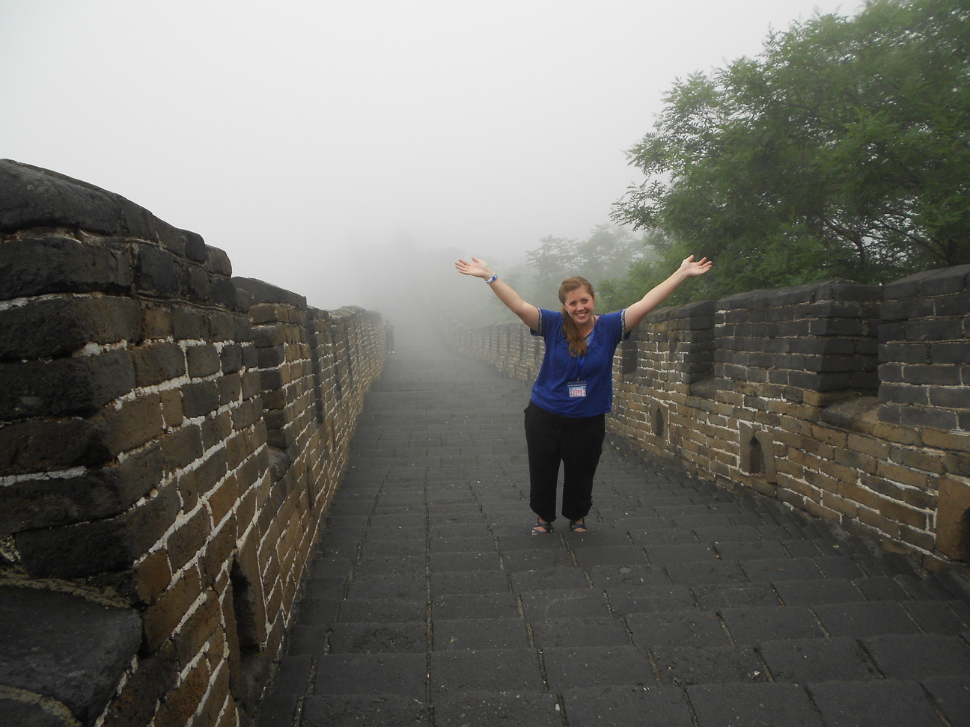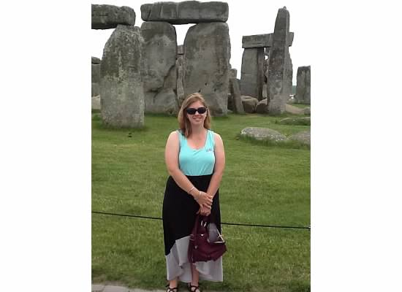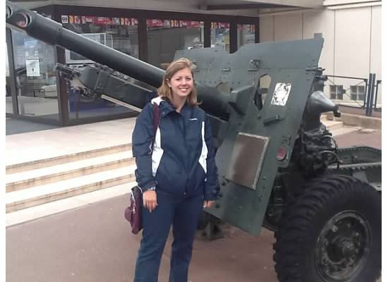

\*Here I am on the Great Wall, at Stonehenge, and with a piece of WWII artillery in Normandy. Please include a photo of you on your letter.